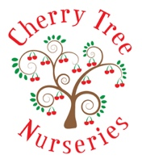
Fees Policy
Reviewed August 2022

All fees are to be paid by bank transfer or cash. We do not accept cheques

Fees are due on the 28th of every (previous) month. After the 1st day of the month a £5.00 will be administered daily until the fees are received. If we have not received fees by the 10th of the month Cherry Tree Nurseries can/will exclude your child from Nursery until the fees are paid. If your child is accessing funded hour – your child will be excluded for the paid extra hours, however if payment still is not received by the 15th of the month then child will be excluded for all hours that the attend at nursery.

The invoice given will show the amount of fees you have to pay and any deductions to be made e.g overpayment etc
There is no reduction for holidays, sickness, bank Holidays, emergency closures or Christmas Closure
£6.50 per hour extra if required
We do not swap sessions, however you can book an extra session at the current rate of fees
We accept Nursery Vouchers and also the Funding issued by the local council
If you wish to make payment via your bank, please ask the Nursery Manager for the bank details
To be reviewed August 2023

